

## B.E. SEMINAR REPORT

## On

# “Arduino Assisted Vending Machine with RFID Technology.”

Submitted by,

Atharv Aher

Om Gali

Suraj Haral

UNDER THE GUIDANCE OF

**Dr. Gopal Gawande (Internal Guide)**

IN PARTIAL FULFILMENT OF

B.E. (ELECTRONICS & TELECOMMUNICATION) SAVITRIBAI PHULE PUNE UNIVERSITY

2022-2023

MARATHAWADA MITRA MANDAL’S COLLEGE OF ENGINEERING, PUNE- 52

DEPARTMENT OF ELECTRONICS AND TELECOMMUNICATION



MARATHAWADA MITRA MANDAL’S

**COLLEGE OF ENGINEERING, PUNE**

**CERTIFICATE**

This is to certify that the seminar report entitled

Submitted by

Athrav Aher Exam No: -

Om Gali Exam No: -

Suraj Haral Exam No: -

is Bonafede work carried out by them under the supervision of

Prof. Dr. Gopal Gawande (Internal Guide) and iit isapproved for the

partial fulfilment of requirement of Savitribai Phule Pune University

for award of the degree of Bachelor of Engineering

(Electronics and Telecommunication).

This seminar report has not been earlier submitted to any other Institute or University for the award of any degree or diploma.

Dr. Gopal Gawande

Name of Project Guide

Department of E&TC

Dr. G. S. Gawande

Head of Department

Department of E&TC

Dr. V. N. Gohokar

Principal

Place: Pune Date:

### INDEX

**1. Chapter 1...................................................................................................**

1.1 Introduction.........................................................................................

### 2. Chapter 2...................................................................................................

2.1 Literature Survey..................................................................................

**3. Chapter3…................................................................................................**

3.1 Block Diagram..................................................... ...................

### 4. Chapter 4...................................................................................................

4.1 Circuit Diagram… ...............................................................................

4.2 Hardware Implementation and Working .............................................

**5. Chapter 5...................................................................................................**

5.1 Methodology...............................................................................

**6. Chapter 6...................................................................................................**

6.1 Flowchart...................................................................................................

6.2 Advantages

6.3 Disadvantages

6.4 Applications

6.5 Conclusion

6.6 Future Scope

6.7 Schedule

### REFERENCES

**LIST OF FIGURES**

|  |  |  |
| --- | --- | --- |
| **Sr. No.** | **Name of Figure** | **Page No.** |
| 3.1 | Block Diagram | 14 |
| 4.1 | Circuit Diagram | 18 |
| 4.2 | Pin diagram | 21 |
| 4.3 | RFID reader | 23 |
| 4.4 | Smart Card | 23 |
| 4.5 | LCD | 25 |
| 4.6 | Servo motor | 26 |
| 4.7 | Buzzer | 28 |

# ABSTRACT

In this contemporary dynamic automated world, every product is smart and mechanized, all of the human desires are met with the aid of using shrewd gadgets. The automatic vending machine presents the packed meals items. These systems are operated with mixture of manually operated transfer buttons in conjunction with RFID tag.

This task is achieved by the use of machine which operates on four independent servo motors as an actuator with recognize to the Arduino Uno and Atmega 328. The automated merchandising gadget can be used to serve the essential packed food items withinside the industrial and commercial hotspot areas. The automated vending machine is primarily based totally on the ‘EMBEDDED SYSTEMS’. The product tackles the want of carrying personalized essential food items and allows the consumer to reap the packed food on any deployed location. The vending gadget additionally promotes cashless transactions to mitigate the demand of conventional payment modes to the enforce simpler vending answer that makes use of RFID tags. This mission makes use of RFID technology, the contactless payment systems is used to identify an individual uniquely with the assist of the unique code saved in the RFID tag as this technology promotes cashless transaction. Due to the unique code, a person is capable to vend a packaged product at any defined instance for the required and respective quantity. The designed vending gadget may be deployed in numerous industries, organizations, academic establishments etc. The common consumers and target customers are employees, workers, and students. The RFID tag can be accessed and the precise product can be selected ultimately resulting into the gadget vending the product at the same time as the corresponding amount and the quantity can be saved within the logs and can be deduced later respectively.

## ORGANISATION OF REPORT

This project “**Automatic Vending Machine using RFID**.” is thoroughly explained in all the chapters in this report. Planning and organization of this subject has been done with curiosity and as per the given deadline. So, this project gives the entire overview of this subject.

The report is divided into various chapters to understand each aspect of the subject technically and separately.

### Chapter 1:

Gives brief introduction of this project. This consist of introduction and scope of project, objective of this project.

### Chapter 2:

Gives brief review of the related Literature and present scenario of proposed system.

### Chapter 3:

Describes System Schematic & Specification and block diagram with its detailed explanation.

### Chapter 4:

Describes the implementation of the project with its hardware and software description that is detailed analysis of each component.

### Chapter 5:

Conclusion, Future Scope and Project Planning.

**Chapter 6:**

Other Specifications.

# CHAPTER 1

# INTRODUCTION



### INTRODUCTION

The automated dispensing machine implemented on ground level is known as the vending machine. The Vending system is an automated gadget that serves and dispenses packed meals items and products. The product implementation deals with automated gadget in real-time with a goal of serving of packed food products at convenience for consumers.

The project introduces the system working with the wireless transactions using RFID tags as storing traditional currency such as banknotes and coins can be a limiting factor as storage space is a crucial issue in small vending machines.

The Radio frequency identification technology introduced a new type of cashless vending system, replacing normal cash-based methods at vending machines. The additional features added to RFID virtual machines are security and convenience. This technology allows access only via RFID, which prevents the machine from being misused.

A RFID is a low-cost, secure wireless electronic identification technology compatible with a capacitive-inductive resonance system. This technology includes radio frequency (RF) and electromagnetic fields. The battery-free passive RFID tag package includes the RFID card and the RFID reader are operating at frequency of 13.56MHz.

A RFID reader is installed in the vending device, which handles the authentication and validation of unique tag card information. The card with the RFID tag is made available to each department of an institution or company. The vending machine is supported by the Arduino Uno microcontroller paired with Atmega 328 IC and interfaced with buttons for to complete the vending machine integrated system.

# CHAPTER 2 LITERATURE SURVEY



### 2.1 LITERATURE SURVEY

In [1] the author Sarika Oundhakar has defined about all-encompassing solution to an individual seeking out instant symptomatic alleviation for trivial health troubles. It can also decrease the present-day expenses of open medicine cabinets. By having an over the counter vending gadget within the workplace, worksites with out clinics or pharmacies can gain from accelerated work performance and keep away from underperformance of unwell employees. Moreover, it prevents hours wasted ready in queues at clinics for trivial troubles like colds and headaches. This state of affairs receives mainly magnified whilst a area is affected by a localized epidemic or pandemic.

The approach utilized by author Malashree.G in [2] is developing All Time Medicine (ATM). This is a gadget which supplies the medication in emergency instances and make certain availability of medication 24x7 and consequently the name “All Time Medicine”. ATM could be very beneficial in saving life in case of an twist of fate on highways, remote regions, rural regions and locations wherein clinical shops aren't in the attain in case of emergency. At least first useful resource may be made effortlessly available with the assist of this device. This venture includes Advanced RISC Machine PIC micro controller which controls the alternative sub structures which include RFID Reader, Global System for Mobile communication (GSM), remedy dispenser, stock manipulate. RFID tag identifies the precise user. GSM sends the message to the stock manage whilst the drugs want to be refill.

In the [3] the author J.Paruvathavardhini has defined how the automated vending gadget may be used to serve the critical needs to the humans withinside the business sectors. In Today's era the vending gadget is call for is rapid growth. The fast paced and busy human beings neglect about to hold their very own vital wishes with them, they choose to get the matters from wherein they are, and so the vending machines can resolve their urge. But in recent times humans favor to use virtual payment alternatives rather than coins to keep away from the cashless related to wearing coins. So to mitigate the call for for contemporary payment modes, the put in force virtual price device that makes use of RFID tag. This device offers the get entry to handiest thru RFID which avoids the misuse of gadget. Here, the have designed a merchandising gadget for the instructional establishments which may be utilized by the students to vend the vital needs like first useful resource drugs, masks, sanitary napkins, etc. final quantity and the stability wide variety of the goods may be displayed withinside the LCD display.

The author Vishal Tank explained in [4] that access to primary health care is an important pillar of development to build a healthy future. This is achived by machine. The communication between the Raspberry Pi and the Arduino controllers is serial via a USB cable. Power supply via a normal 230 V socket (alternating current). Due to the physical and infrastructural limitations of setting up a medical camp in remote areas, this machine was designed as a self-contained unit that requires minimal supervision to operate over long periods of time. time.The method used by Rajani Karalgikar in [5] describes the use of a vending machine to dispense water. The machines are the ones that dispense the water for free. Flowing substances like water, oil, food, drink etc. To help the public, the government had already created the facility to provide clean drinking water with the coin-based water dispenser, where by inserting a coin, the system dispenses the purified water on demand .This project uses RFID technology, the non-contact technology used to uniquely identify the person or object using the unique code in tag.

In [6] Govind Sopan Waghmare describes how important feminine hygiene is and the need of buying sanitary napkins in medical supply stores and other shops. One solution to this problem is to install a sanitary napkin dispensing system. people in an emergency without going to a pharmacy. It is a microcontroller and motor based system for dispensing medication when accessed by the user via an input event. aims to install automatic sanitary napkin dispensers in toilets and places such as long highways and remote tribal areas by using an online payment gateway. This increases the availability of sanitary napkins in the system at once, so no need to fill the napkins in the system. regularly.

# CHAPTER 3

# SYSTEM SCHEMATIC AND SPECIFICATION



### 3.1 BLOCK DIAGRAM

### In the figure (3.1), The vending machine has AtMega328 that acts as a master controller along with RFID tag and reader. The external devices such as keypad, display is often Connected through the varied pins on the AtMega328. Initially, The RFID tag is scanned and later the user is allowed to select the product as per the individuals needs. This will be operated by using Arduino IDE platform and Embedded C programming language software.

### 

### Fig: 3.1 Block diagram of Automatic Vending Machine using RFID

### 3.1.1 PROPOSED SYSTEM

### The vending machine is powered by an external DC power supply that is fed to the Arduino Uno R3 microcontroller, which is connected to the AtMega328 IC that acts as the main processor. The AtMega328 is the master controller that controls the entire system along with the RFID tag and reader. Devices like the display, buttons, and switches are connected via GPIO pins on the Arduino, which is connected to the Atmega328. This system forms the vending machine, which is controlled by the Arduino microcontroller to perform the given task of dispensing the packaged food product.

### 3.1.2 EXISTING SYSTEM

### In the conventional vending machines, the microcontroller or processor is employed for the entire process and their coding is additionally complex. It accepts traditional tangible currency and senses the inserting of coin through the currency inlet. This system is vulnerable as it accepts fake with same density and same size inserted to the coin inlet and the products are often delivered without sensing the fake coins, this may be considered because the major drawback of this existing machine.

**3.1.3 Working:**

Initially, vending machines received external DC power directly from the Arduino Uno board's input power supply. The Atmega 328 is connected to a microcontroller and acts as the main processor. The 4 independent servo motors and RFID systems are connected to the analog pins of the Arduino microcontroller. External devices such as switches, knobs and LCD displays are often connected to the Arduino Uno's digital GPIO pins. The unique RFID card isScanned and authenticated allows the user to select the packaged food among the different items. The servo motor is connected to the spiral ring, the products placed in the ring are output one at a time. Finally, the packaged food is selected using a button that starts the rotation of the motor and then the motor spins to deliver the packaged food at a time.

**3.1.4 Hardware components:**

1. MICROCONTROLLER- Arduino Uno R3
2. Integrated Circuit- AT mega 328
3. Power Supply 12v
4. Button X 4
5. Servo motors X 4
6. Buzzer
7. LED

**3.1.5 Software required:**

1. Arduino IDE (Embedded C)
2. Express PCB (Schematic design )
3. Proteus (Simulation)

# CHAPTER 4

# SYSTEM DESIGN HARDWARE



### This chapter covers the design of hardware. The proteus has been used as the simulation software. The hardware implementation thoroughly explains all the aspects of the hardware systems of the project with curiosity and as per the given deadline and provides an entire overview of the product as given below.

### 4.1 Circuit Diagram

### 

### Fig 4.1: circuit Diagram

### 

### The circuit diagram (4.1) contains pin configuration interfacing unit to which servo motors are connected to the PD4, PD5, PD6, PD7 and LCD display is connected to digital pins of controller Port B. The power supply of system contains the transformer and regulator 7805 which gives fixed 5v for microcontroller.

### 4.2 HARDWARE IMPLEMENTATION AND WORKING

**4.2.1 AVR Microcontroller (ATmega328)**

The ATmega328 is a single-chip microcontroller created by Atmel in the megaAVR

family. It based on the modified Harvard architecture 8-bit RISC processor core 10 Microcontroller Atmega 328.

Features

• High Performance, Low Power AVR® 8-Bit Microcontroller

• Advanced RISC Architecture

– 131 Powerful Instructions – Most Single Clock Cycle Execution

– 32 x 8 General Purpose Working Registers

– Fully Static Operation

– Up to 20 MIPS Throughput at 20 MHz

– On-chip 2-cycle Multiplier

• High Endurance Non-volatile Memory Segments

– 4/8/16/32K Bytes of In-System Self-Programmable Flash program memory

– 256/512/512/1K Bytes EEPROM

– 512/1K/1K/2K Bytes Internal SRAM

– Write/Erase Cycles: 10,000 Flash/100,000 EEPROM

– Data retention: 20 years at 85°C/100 years at 25°C

– Optional Boot Code Section with Independent Lock Bits

In-System Programming by On-chip Boot Program

True Read-While-Write Operation

– Programming Lock for Software Security

• Peripheral Features

– Two 8-bit Timer/Counters with Separate Prescaler and Compare Mode

– One 16-bit Timer/Counter with Separate Prescaler, Compare Mode, and Capture

Mode

– Real Time Counter with Separate Oscillator

– Six PWM Channels

– 8-channel 10-bit ADC in TQFP and QFN/MLF package

Temperature Measurement

– 6-channel 10-bit ADC in PDIP Package

Temperature Measurement

– Programmable Serial USART

– Master/Slave SPI Serial Interface

– Byte-oriented 2-wire Serial Interface (Philips I2C compatible)

– Programmable Watchdog Timer with Separate On-chip Oscillator

– On-chip Analog Comparator

– Interrupt and Wake-up on Pin Change

• Special Microcontroller Features

– Power-on Reset and Programmable Brown-out Detection

– Internal Calibrated Oscillator

– External and Internal Interrupt Sources

– Six Sleep Modes: Idle, ADC Noise Reduction, Power-save, Power-down, Standby,

and Extended Standby

• I/O and Packages

– 23 Programmable I/O Lines

– 28-pin PDIP, 32-lead TQFP, 28-pad QFN/MLF and 32-pad QFN/MLF

• Operating Voltage:

– 1.8 - 5.5V

• Temperature Range:

– -40°C to 85°C

• Speed Grade:

– 0 - 4 MHz@1.8 - 5.5V, 0 - 10 MHz@2.7 - 5.5.V, 0 - 20 MHz @ 4.5 - 5.5V

• Power Consumption at 1 MHz, 1.8V, 25°C

– Active Mode: 0.2 mA

– Power-down Mode: 0.1 μA

– Power-save Mode: 0.75 μA (Including 32 kHz RTC)

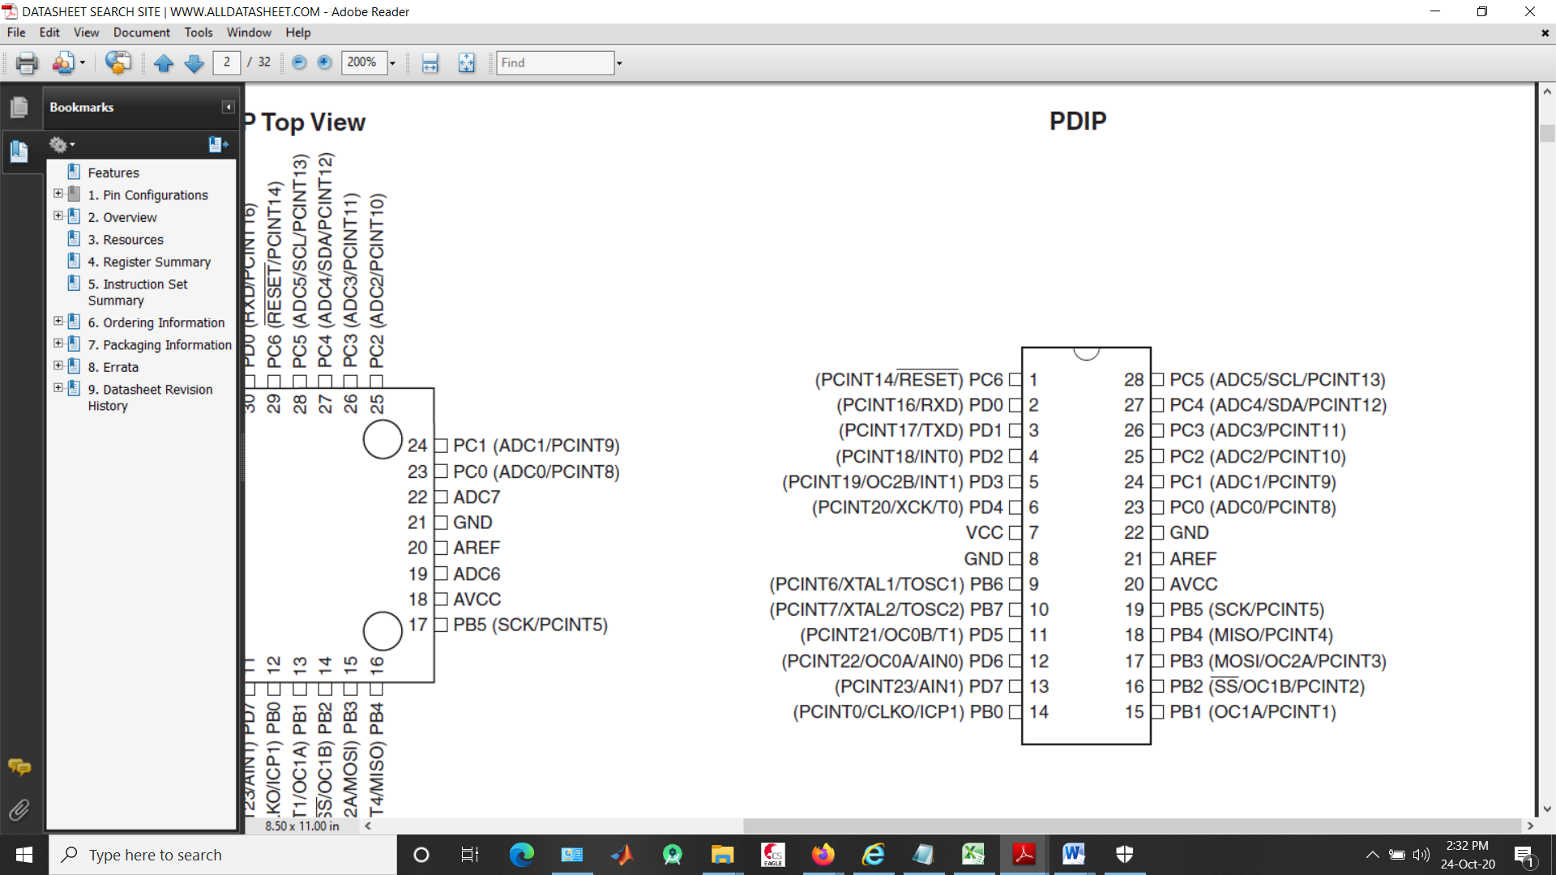

Fig 4.2 Pin diagram

### 4.2.2 AVR Microcontrollers

### AVR is a type of microcontrollers, also known as AVR family microcontrollers, used to develop embedded systems. Atmel introduced the AVR family of microcontrollers in 1996 and was later acquired by Microchip Technology in 2016. The main feature of the AVR controllers was that they were the first families of microcontrollers to use on-chip flash memory, while all other microcontrollers at the time used ROM, EPROM or EEPROM.

**4.2.3 Pin Descriptions**

**1.1.1 VCC Digital** supply voltage.

**1.1.2 GND** Ground.

**1.1.3 Port B (PB7:0) XTAL1/XTAL2/TOSC1/TOSC2**

Port B is an 8-bit bidirectional I/O port with internal pull-up resistors (selected for each bit). Port B output buffers have balanced unit characteristics with high sink and source capacitance. As inputs, port B pins that are externally pulled supply current when the pull-up resistors are on. Port B pins are triple set when a reset condition is triggered, even if the clock is not running. Depending on the Clock Select Fuse setting, PB6 can be used as an input for the 's inverting oscillator amplifier and as an input for the internal clock driver circuitry.Depending on the Clock Select Fuse setting, PB7 can be used as the output of the inverting oscillator amplifier. If the internal calibrated RC oscillator is used as chip clock source, PB7...6 is used as input TOSC2...1 for asynchronous timer/counter2 if bit AS2 in ASSR is set.The various special features of port B are explained in detail under "System clock and clock options"

**1.1.4 Port C (PC5:0)**

Port C is a 7-bit bi-directional I/O port with inner pull-up resistors (decided on for every bit). The C5 zero output buffers have symmetrical pressure traits with each excessive sink and supply capability. As inputs, Port C pins which might be externally pulled low will supply contemporary if the pull-up resistors are activated. The Port C pins are tri-said whilst a reset circumstance turns into active, even though the clock isn't running.

**1.1.5 PC6/RESET**

If the RSTDISBL Fuse is programmed, PC6 is used as an I/O pin. Note that the electrical characteristics of PC6 differ from those of the other pins of Port C. If the RSTDISBL Fuse is unprogrammed, PC6 is used as a Reset input. A low level on this pin for longer than the minimum pulse length will generate a Reset, even if the clock is not running.

**1.1.6 Port D (PD7:0)**

Port D is an 8-bit bidirectional I/O port with internal pull-up resistors (selected for each bit). Port D output buffers have symmetric drive characteristics with high sink and source capacity. As inputs, port D pins that are externally pulled supply current when the pull-up resistors are on. Port D pins are tri-stated when a reset condition is triggered, even if the clock is not running.

**4.2.4 RFID reader and tag**

In (4.3) the RFID Radio Frequency Identification is a generic term for non contact technology It works at the lowest frequency of 125kHz to clearly identify the person or object. It is compact and can be connected directly to the PC via the RS232 protocol. Stores the unique number that identifies a person or object attached to an antenna. The combination of antenna and microchip is collectively referred to as an "RFID tag" and works in combination with an "RFID transponder".

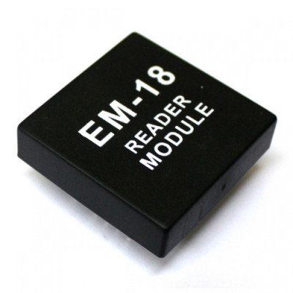

Fig. 4.3 RFID reader



Fig. 4.4 Smart Card

**4.2.6 LCD Display**

LCD (2*16) is an electronic display module and finds a variety of applications. The 2x16 LCD display is an extremely simple module and is very often used in various devices and circuits. These modules are preferred over other seven-segment and other multi-segment LEDs. The reason for this is that LCDs are cheap, easy to program and have no restrictions on displaying animations and special characters and even custom characters.

### LCD 2x16 Pin Diagram

The 2×16 LCD pin out is shown below (figure 4.5):

* Pin1 (Ground/Source Pin): This is a GND pin of display, used to connect the GND terminal of the microcontroller unit or power source.
* Pin2 (VCC/Source Pin): This is the voltage supply pin of the display, used to connect the supply pin of the power source.
* Pin3 (V0/VEE/Control Pin): This pin regulates the difference of the display, used to connect a changeable POT that can supply 0 to 5V.
* Pin4 (Register Select/Control Pin): This pin toggles among command or data register, used to connect a microcontroller unit pin and obtains either 0 or 1(0 = data mode, and 1 = command mode).
* Pin5 (Read/Write/Control Pin): This pin toggles the display among the read or writes operation, and it is connected to a microcontroller unit pin to get either 0 or 1 (0 = Write Operation, and 1 = Read Operation).
* Pin 6 (Enable/Control Pin): This pin should be held high to execute Read/Write process, and it is connected to the microcontroller unit & constantly held high.
* Pins 7-14 (Data Pins): These pins are used to send data to the display. These pins are connected in two-wire modes like 4-wire mode and 8-wire mode. In 4-wire mode, only four pins are connected to the microcontroller unit like 0 to 3, whereas in 8-wire mode, 8-pins are connected to microcontroller unit like 0 to 7.
* Pin15 (+ve pin of the LED): This pin is connected to +5V
* Pin 16 (-ve pin of the LED): This pin is connected to GND.

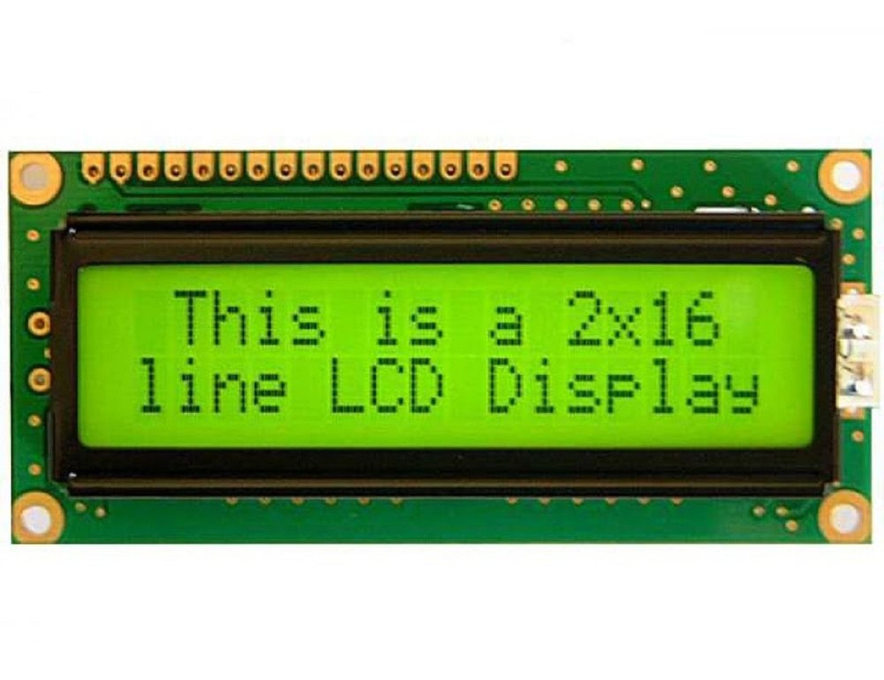

### Fig: 4.5 LCD 2×16 Pin display

### Features of LCD2x16

The features of this LCD mainly include the following.

The operating voltage of this LCD is 4.7V-5.3V

* It includes two rows where each row can produce 16-characters.
* The utilization of current is 1mA with no backlight
* Every character can be built with a 5×8 pixel box
* The alphanumeric LCDs alphabets & numbers
* Is display can work on two modes like 4-bit & 8-bit
* These are obtainable in Blue & Green Backlight

**Specifications of 2x16 LCD Display Module:**

* Operating Voltage: 4.7V to 5.3V.
* Operating Current 1mA (without backlight)
* Can display (16x2) 32 Alphanumeric Characters.
* Custom Characters Support.
* Works in both 8-bit and 4-bit Mode

**4.2.7 Servo Motor**

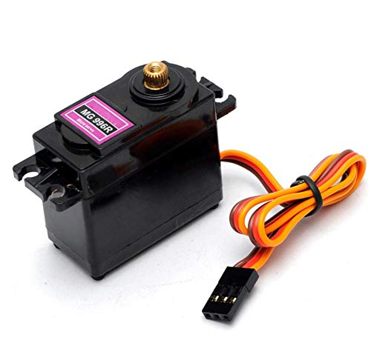This High-Torque MG996R Digital Servo features metal gearing resulting in extra high 10kg stalling torque in a tiny package. The MG996R is essentially an upgraded version of the famous MG995 servo, and features upgraded shock-proofing and a redesigned PCB and IC control system that make it much more accurate than its predecessor. The gearing and motor have also been upgraded to improve dead bandwidth and centring. The unit comes complete with 30cm wire and 3 pin 'S' type female header connector that fits most receivers, including Futaba, JR, GWS, Cirrus, Blue Bird, Blue Arrow, Corona, Berg, Spektrum and Hitec. This high-torque standard servo can rotate approximately 120 degrees (60 in each direction). You can use any servo code, hardware or library to control these servos, so it's great for beginners who want to make stuff move without building a motor controller with feedback & gear box, especially since it will fit in small places. The MG996R Metal Gear Servo also comes with a selection of arms and hardware to get you set up nice and fast!

Fig 4.6 Servo motor

# The Servo motors are used in this project as they can be controlled with precision of a single degree angle.

# Specification

# 

# 

**4.2.8 BUZZER**

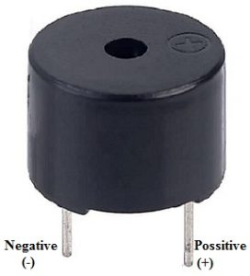

Fig:4.7 BUZZER

In Figure (4.7), an audible signaling device such as a beeper or buzzer can be electromechanical, piezoelectric or mechanical. The main function is to convert the audio signal into sound. Generally, it is powered by DC voltage and used in timers, alarms, printers, alarms, computers, etc. Based on the different designs, it can produce different sounds like alarm, music, bell and siren.

**Specifications**

* The frequency range is 3,300Hz.
* Operating Temperature ranges from – 20° C to +60°C.
* Operating voltage ranges from 3V to 24V DC.
* The sound pressure level is 85dBA or 10cm.
* The supply current is below 15mA.

# CHAPTER 5 PROJECT PLANNING

# AND METHODOLOGY



In this chapter the methodology and information about the project is described.

**5.1 Methodology**

Vending machines are the one which dispense the goods inclusive of chocolates, beverages, snacks and plenty of different things. The programs of merchandising device are in numerous fields. The flowchart [ 6.1 ] offers the experimental setup of the automatic packed meals distribution machine primarily based totally on RFID and Embedded systems. This task makes use of RFID generation wherein the contactless generation is used to discover the character or item uniquely with the assist of the particular code saved in it. This generation promotes cashless transaction. Based at the particular code the character is ready vend the enough quantity of meals merchandise at a described time and the quantity is deducted after each use of the card.

# CHAPTER 6

# OTHER SPECIFICATIONS

# This chapter specifies the algorithm and other specifications of the project. It contains advantages, disadvantages and the application of the vending machine.

**6.1 FLOWCHART**

The flow chart states the complete algorithm to show the working of the embedded system with respect to automated vending machine.

Give Input

Read RFID

YES

If Serial= valid data

**No**

Check selection Key

Take Action as per selection

Display information on LCD display

**6.2 Advantages of vending machines**

The advantages of vending machine are stated as follows:

1. We can have diversity of products for sale.
2. Convenience is much higher.
3. Various payment methods are available.
4. There is mobility towards products.
5. It is easy to manage.
6. Cost saving approach as no need of manpower.

## 6.3 Disadvantages of vending machines

The Vending machines are usually located in a specific location and work automatically without anyone managing them. Therefore, the machine faces the challenge of detecting fraud or hacking into the machine's system to obtain products. The state of machine destruction caused by groups of thugs or competitors hating each other. Faced with these situations, choosing a safe place for machine location for remote monitoring and have the best machine protection plans to minimize the risks.

The vending machines bring many benefits, suitable for the development of today's society, and attract many investors. However, if the business with this model, the disadvantages solutions overcome them in order to achieve the best business results.

**6.4 Applications:**

The automated packed food distribution system based on RFID and embedded system can be used in following:

* Schools
* Colleges
* Railway station
* Bus stops
* Medicals
* Shops
* Industries
* Cafeterias

### 

### 6.5 CONCLUSION

### The project concludes that the user need to scan a RFID card and press a button of user choice and the vending machine will dispense the corresponding item for user. This RFID based Vending Machine is majorly using four hardware which are Arduino Uno, four independent servo motors, LCD display, RFID card and 12V power supply. There are four buttons for selecting the items in the four chambers. The LCD display will display the message and instructions to operate the Machine. This system is portable and affordable, it also consumes less power. The machine can be made easily available so that the user can use this system whenever and wherever.

### 6.6 FUTURE SCOPE

There is a futuristic scope toward the merchandising device as humans are adapting more healthy existence and there may be a call for for healthful snacks and drinks on the administrative centre in addition to in schools, colleges, organization corporations etc. This call for and capacity is best going to growth withinside the destiny which goes be happy and exponentially improved with the aid of using using merchandising device. With improved public challenge approximately the environment, it's far vital to pursue concord among environment-pleasant and human pleasant products. Vending machines having increase capacity similarly to the delight of buying, are clean to operate.

### 6.7 SCHEDULE

|  |  |  |  |  |  |  |  |  |  |  |
| --- | --- | --- | --- | --- | --- | --- | --- | --- | --- | --- |
| **Sr.**  **No.** | **Activity** | **Duration** | | | | | | | | |
|  | | **01**  **months** | **01**  **Months** | **01**  **months** | | **01**  **months** | **01**  **months** | **01**  **moths** | | **01**  **months** |
| **1** | **Literature**  **Survey and Block**  **Diagram**  **Finalization** | July - August | |  | | | | | | |
| **2** | **Design of Circuit**  **Diagram of the system.** |  | August - September | | |  | | | | |
| **3** | **Material Procurement and Hardware Testing.** |  | | | October - November | | |  | | |
| **4** | **Final Design**  **implementation and Experimentation** |  | | | | | January - March | | |  |
| **5** | **Result and Report Preparation** |  | | | | | | | April - May | |

**6.8 REFRENCES:**

1. “*Automatic Medicine Vending Machine”*, Sarika Oundhakar, India International Journal of

Engineering Technology Science and Research IJETSR ISSN 2394 – 3386 Volume 4, Issue 12 December 2017.

1. *“AUTOMATIC MEDICINE VENDING SYSTEM-MEDICAL ATM”* M Sangeetha, T V Janardhan Rao, Ch. S Rama Gowri, ISSN: 2455-2631© October 2016 IJSDR | Volume 1, Issue 10 IJSDR1610031 International Journal of Scientific Development and Research (IJSDR).
2. “*ATM (All Time Medicine) Counter for Medicine Self-Dispensing”,* Malashree.G, Ubaidulla, Shilpa R S, Divya U, International Journal of Latest Technology in Engineering, Management & Applied Science (IJLTEMAS) 1st Special Issue on Engineering and Technology | Volume VI, Issue VS, May 2017 | ISSN 2278-2540.
3. “*Autonomous All Time Medicine Counter for Medicine Self Dispensing*”, Srividya C N, Munisahana M, Navyashree N S, Nikhil Gowda T K, May-2019, www.ijraset.com, (IJRASET).
4. “*Medicine Dispensing Machine Using Raspberry Pi and Arduino Controller*”, Vishal Tank, Sushmita Warrier, Nishant Jakhiya, IEEE Conference on Emerging Devices and Smart Systems, March-2017.
5. “*Automatic Medicine Vending System-Medical ATM*”, M Sangeetha, T V Janardhana Rao, Ch Rama Gowri, IJSDR, October-2016, www.ijsdr.org.
6. “*The Autonomous Pill Dispenser with Alarm and Mobile Notifications*”, Jayesh Patil, Sameer Khairmode, Rishikesh Lokhande, Omkar Shinde ISSN: 2321-9653, IJRASET, www.ijraset.com, April-2019.
7. “*A Smart Pill Box with Remind and Consumption Using IoT*”, Shashank Shinde, Tejas Kadaskar, Pushpak Patil, Rohit Barathe, www.irjet.net, December2017.
8. “*Design and Implementation of Automatic Medicine Dispensing machine*”, Mahaveer Penna, Dankan V Gowda, Jijesh J J, Shivashankar, IEEE International Conference (RTEICT), May-2017.
9. “*Smart Pill Box Using IoT*”, Naga Swetha R, Mahendra, Roopsingh, Chinna, ISSN: 2393-8374, 2018.
10. “*Prototype Implementation of RFID based health management system with low-power ARM microcontroller*”, Naga Swetha R, Mahendra, Roopsingh, Chinna, IEEE Annual Consumer Communications & Networking Conference, 2018.
11. “*Implementation of FSM Based Automatic Dispense Machine with Expiry Date Feature Using VHDL*”, Suhail, Beg, International Journal of Modern Engineering Research (IJMER), vol. 4, p.p. 1-5, April 2014.
12. “*Touch Screen Based Automated Medical Vending Machine,*” Singh, International Journal for Innovative Research in Science & Technology (IJIRST), vol. 1, p.p. 1-4, April 2015.
13. “*Solar Powered IOT Based Intelligent Sanitary Napkin Dispenser*”, K.Samba Siva Rao, K.Harish, M. Kavin Kumar, D. Vishnu Harish, March 2018, International Journal for Research in Applied

Science and Engineering Technology (IJRASET), ISSN:2321-9653, Vol-6, Issue 3,pp.2016 2021.

1. *“Design and Fabrication of Automatic Dispensing Machine*”, Mohan Sukragond, Prafullachandra P Siddeshwar, Pradhyumna D R,Prajwal Setty, International Journal of Research in Advent

Technology, Special Issue may-2018, 3rd National conference on Emerging Trends in Mechanical Engineering (NCETM2018) Available online at www.ijrat.org, pp.20-26.

1. *“Automatic Paper Vending Machine”,* Kamalanathan.P, Irshath Ahmed, Mohamed Aamir, Kalaiselvan.P, April 2015, International Journal of Science, Engineering and

Technology (IJSETR), volume 4, Issue 4, pp.634-639

1. *“Automatic Chocolate Vending Machine by Using Arduino Uno”*, Prof.S.S.Desai, Sayali Maruti Jadhav, Priya Shivaji Patil, Giri Neeta Sambhaji, March2017, International Journal Of

Innovative Research Computer Science Technology (IJIRCST) ISSN: 2347-5552, Volume 5, Issue 2, Pp.226-229

1. *“Case Study on Different Vending Machines”,* Asmita P. Bodhale, Prof.J.S. Kulkarni,April2017,

International Research Journal of Engineering and Technology (IRJET) e-ISSN: 2395-0056, p-ISSN: 2395-0072 Volume: 04 Issue: 04, pp.3531-3535`.